ADAM Optimisation of Hotwire Cutter Trajectory
Rollo D. L. Tully, University of Manchester, MAE
Abstract – Hot-Wire Cutting can rapidly produce prototype components for small Unmanned aircraft but manufacturing accuracy is hard to control due to the complex interactions at the cutting interface, here we present a process that aims to understand and correct this problem?

INTRODUCTION
Hot-wire cutting(HWC) is a subtractive manufacturing method that produces components that can be described by a ruled surface. Hot-wires remove material from the bulk by ablation or melting in a region close to the wire. The size of the region subject to ablation or melting is dependent of a large number of independent parameters. Finding the size of the removed region is a multivariant problem that is common taken to be fixed for large manufacturing operations where the resulting deviation from the desired shape is insignificant. when used in the aerospace applications the exact geometry becomes critical this is particularly critical for small scale aircraft where there small errors compound, small changes in geometry can have dramatic effects on flight characteristics[1] central to this challenge is the manufacture of thin geometries in these cases controlling the amount of latent energy left in the material after the cut is completed becomes important, for the HWC to complete the cut 2 passes must be made near the thin geometry, the heat left in the material from the previous cut increases the amount of ablation on the second pass dramatically altering cutting kerf. Figure 1 Shows how material is lost in regions of thin geometry near the foil trailing edge, foil thickness is also lost along the entire chord length.

This paper aims to realize a method for optimizing the wire trajectory such that the manufactured shape more closely matches the design intent. As a corollary this paper also aims to demonstrate a new method for predicting the material behaviour under cutting conditions.

In this paper a 4 axis CNC hotwire is used (CNC Multitools 1610S) this machine allows for independent control of both the position and velocity of each of the 4 axes, importantly the wire heating is manually set[2].

Motivation
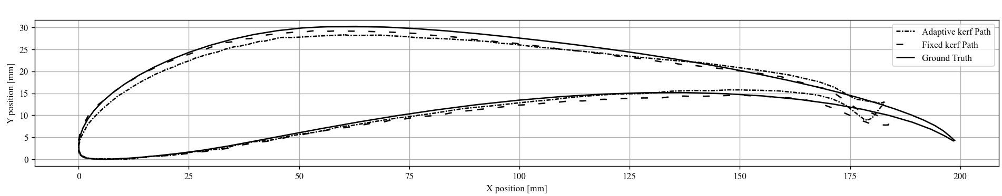
Figure 1. Processed surface geometry from foils manufactured using existing methods, S1223 Foil[3], designed chord length of 200mm, also shown is an existing optimisation method.
Figure 1. shows processed data from a set of 2 foils manufactured using existing methods to generate the machine tool paths, the scans were performed with the EINSCAN HX 3D scanner with 0.2mm resolution. The resulting data shows how the manufactured geometry deviates from the desired geometry(solid line).

As previously shown small deviations in foil geometry can have disproportionate effects on flight performance and characteristics. A central goal to meet design specification results in tight margins and the need to the manufactured geometry to closely match the theoretical performance, we can ensure this by more closely matching the manufactured geometry to the design geometry.
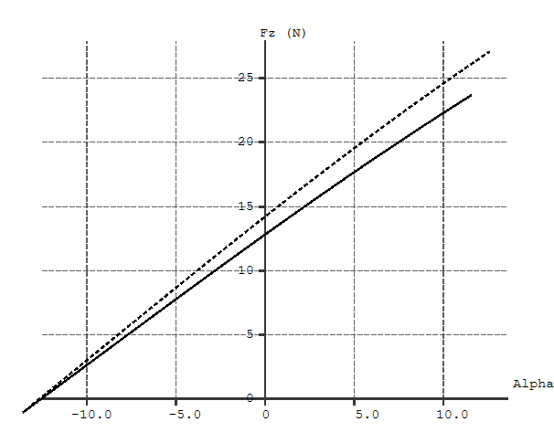
Figure 2. Comparison of theoretical performance of designed foil geometry(Dashed) and manufactured foil geometry(Solid). $V_{0}=10 {ms}^{-1}$ at $R_{e}=130,000$[4].
Figure 2 shows that as a result of manufacturing inaccuracies the manufactured foil geometry has a 10% reduction of lift generated at 0˚ Angle of Attack and Re = 130,000.

Aims & Objectives
The central aim of this paper is as follows:

Develop a method to optimise hotwire trajectory to minimise deviations from the designed surface shape.

This Aim has been broken into a set of quantifiable objectives used to track progress.

OB1. Undertake a testing campaign to quantify magnitude and types of errors for standard tool paths, and for the existing method for correcting these errors

OB2. Research, Develop and implement the a new approach.

OB3. Compare manufacturing quality, computational requirements, and perform trade off analysis.

OB4. Perform Wind Tunnel testing to compare aerodynamic performance.

Methodology
The method developed is into 3 parts:

Material modelling.
We must first robustly predict the resulting shape from a
given wire trajectory. To simplify this problem it is assumed that at the instant ablation at a point ceases the surface specific energy will be a known material dependent value, If a given surface is exposed to more thermal energy than would be required to bring it to this critical surface specific energy the surface will be over ablated and vice versa, it is now only necessary to calculate the cumulative surface thermal exposure at each location to determine if the final shape will be accurately produced.

Thermal modelling
To compute the surface exposure both the wire trajectory and surface geometry are discretised, each panel is defined by 2 points and a vector.

To simplify computation a binary mask is used to track which panels have valid interaction, the mask is formed by taking the sign of the vector cross product of every combination of wire panel and surface panel.
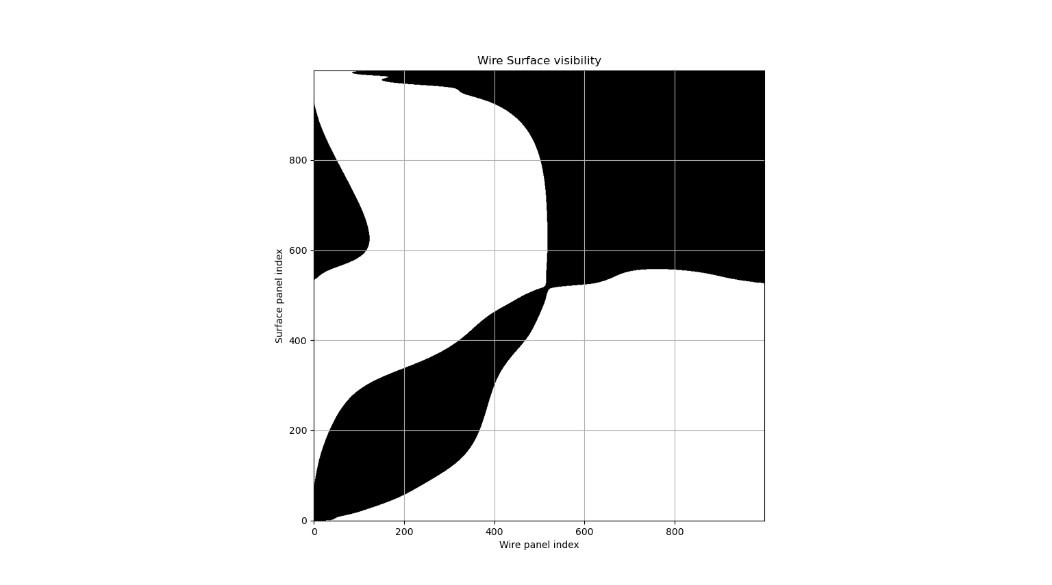
Figure 3. Wire, Surface visibility, Black regions describe regions on the surface that are visible at a chosen wire position
The sign of value in the resulting matrix describes if the wire panel originates from a point to the ‘left’ or ‘right’ of the surface panel vector. The sign chosen is dependent on a combination of foil orientation and surface cutting direction, in our case foils are cut in an anticlockwise direction from foil TE -> LE -> TE, (Trailing edge, Leading edge).

Each point combination is now weighted according to the relative angle between panel vectors and the separations between panels and size of each panel.

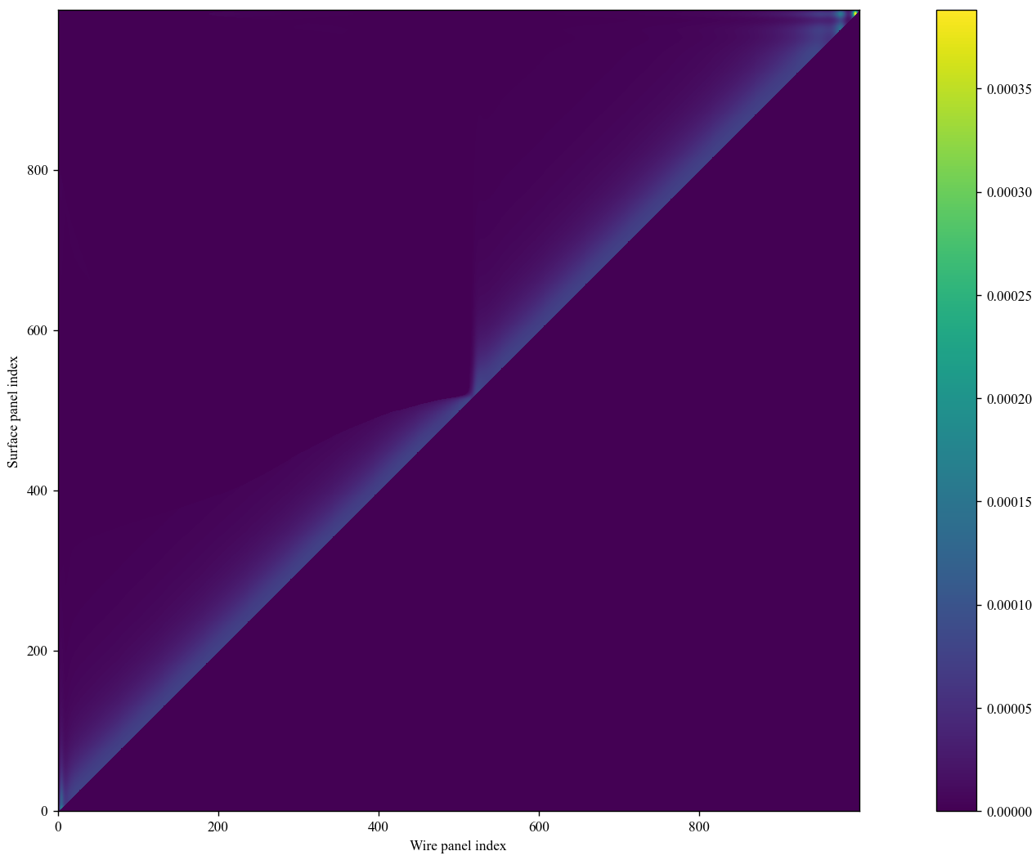
Figure 4. Wire Surface coupling.
Figure 4 shows the exposure of each surface panel as a result of a wire panel, it can be seen that most regions experience similar heating but some regions near the trailing edge experience significantly more heating as a result of the foils geometry.

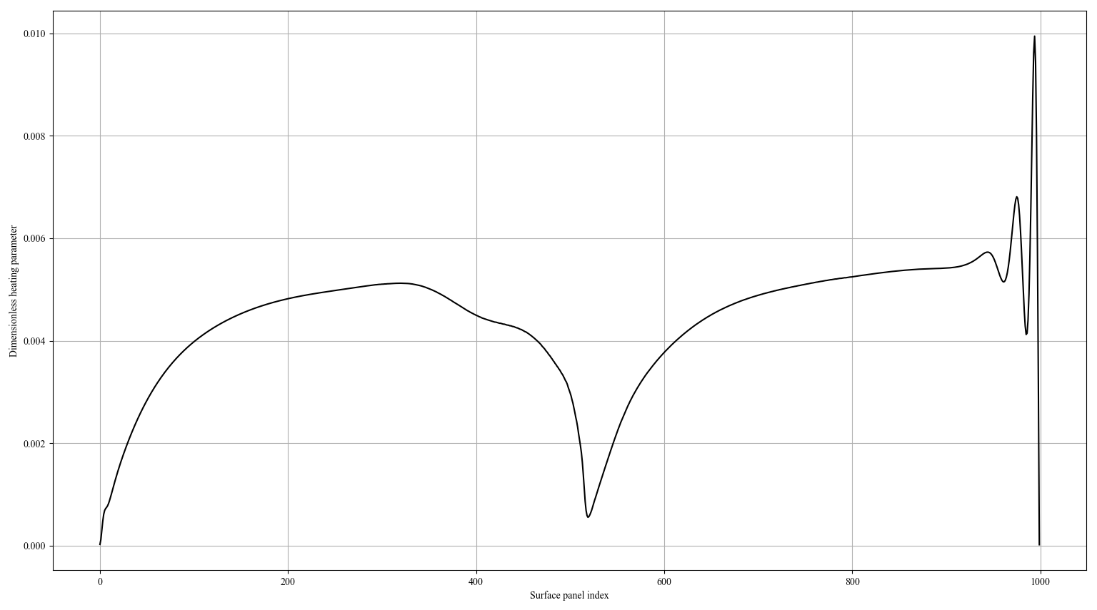
Figure 5. Panel total exposure.
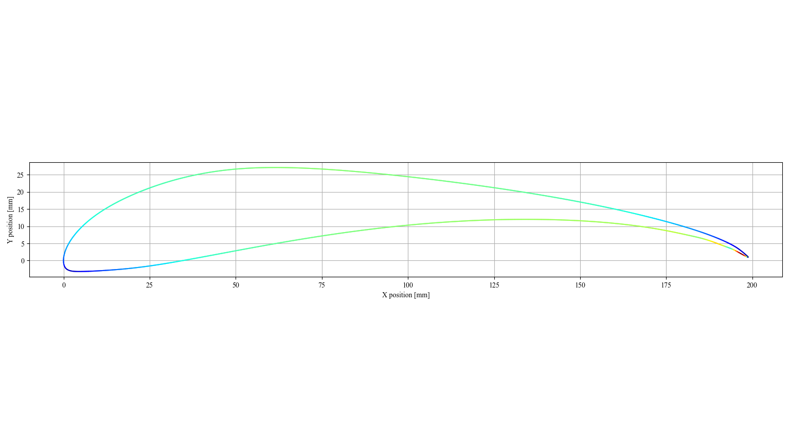
Figure 6. Superimposed panel total exposure
Taking the sum of exposures for each surface panel we arrive at Figure 5, it is clear that although many regions experience similar heating some regions are particularly under or over exposed, superimposing this data onto the foil geometry we arrive at figure 6. Comparing figure 6 to figure 1 that regions with higher exposure are also the regions that most deviate from the desired geometry.

ADAMs path optimisation
Using the developed thermal modelling method we can
now begin optimising the wire trajectory, the goal of the optimisation is for all panels to receive equal exposure, the means that the total ablation will not be well known and a predictable kerf width can be identified.

https://arxiv.org/pdf/1412.6980

References

[1] https://arc.aiaa.org/doi/full/10.2514/1.J063474
[2] https://www.cnc-multitool.com/cnc-hot-wire-cutting-machine-entry-series-cut1610s.html
[3] https://m-selig.ae.illinois.edu/pubs/GuglielmoSelig-1997-JofAC-S1223.pdf
[4]https://www.einscan.com/einscan-hx/
[5] https://www.xflr5.tech/xflr5.htm
[6] https://arxiv.org/pdf/1412.6980

